# HTML and CSS

To get started with HTML and CSS, please see following videos.

1. <https://www.youtube.com/watch?v=OZeoiotzPFg>
2. <https://www.youtube.com/watch?v=yyqvXhu-HOc>

## HTML Task

1. What is HTML? Give basic structure of the HTML page.

HTML stands for Hyper Text Markup Language. It gives structure to the website ie the skeleton of the website. HTML provides you with several tags or components which can be used semantically for better SEO and good looking website

The basic structure of html page is

<!DOCTYPE html>

<html>

<head>

<title></title>

</head>

<body>

</body>

</html>

1. Difference between inline and block level element.

|  |  |
| --- | --- |
| Inline | Block |
| Inline elements consume width sufficient enough to hold the content present in it | Block level elements consume whole horizontal width |
| Starts on the same line if previous element is inline element | Always starts on a new line |
| Allows other inline elements to be placed next to it | Doesn’t allow any inline or block elements to be placed next to it |
| Eg: header tags, p, div | Eg: span, a, img |

1. Create an HTML page “index.htm” with following content

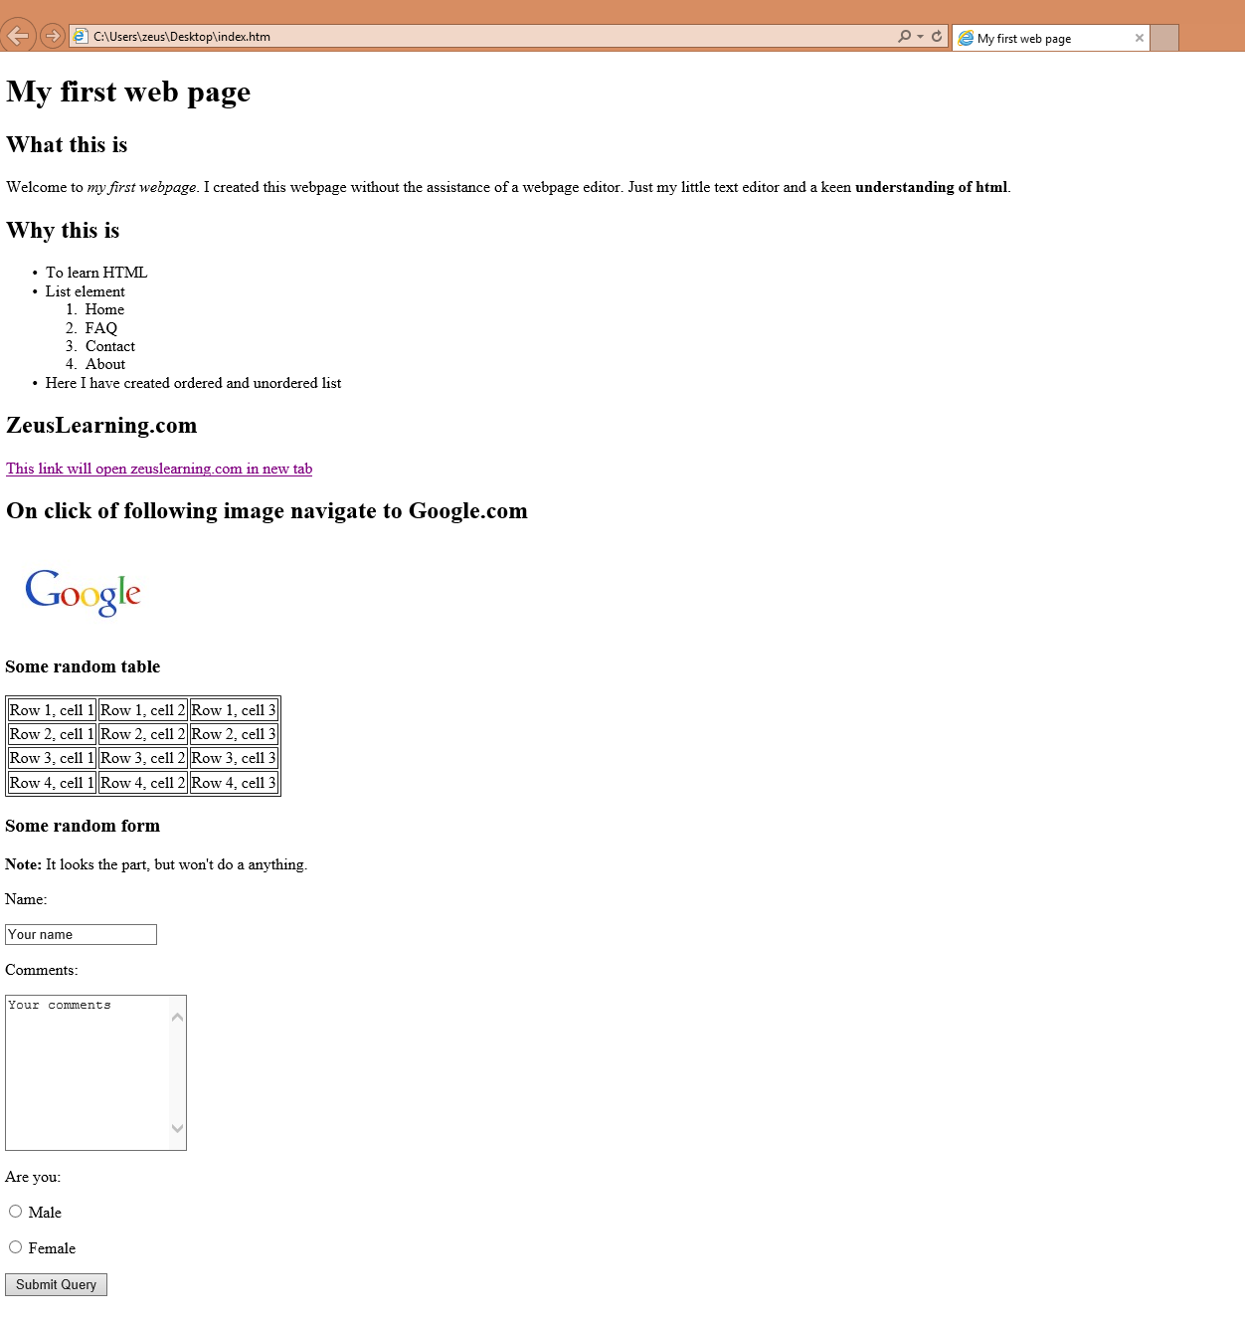

## CSS Task

1. Explain the different ways in which CSS can be applied to HTML, what is the preferred way and why.

Different ways to apply CSS to HTML page is inline CSS (highest priority), internal CSS (higher priority) and external CSS (least priority). This means external CSS can be overridden if for the same element there is an internal CSS rule present and internal CSS can be overridden if there is an inline CSS rule present. It is ideal to use external CSS in development environment so specificity can be better calculated and since HTML is just meant for structuring the website it shouldn’t contain any CSS.

1. What are different CSS selectors, with example explain Element, Class and Id selectors.

CSS selectors are used to select elements from HTML so that. Element selector is basically targeting all element of a type for example p { property : value;}, class selector is used to target html that have been given a class attribute class=”classname”, to select in css, we type .classname{ property: value;} and finally id selector which has the highest specificity, id attribute is provided to element and is targeted using #idname{ property: value;}

1. With the help of a diagram explain CSS Box Model.

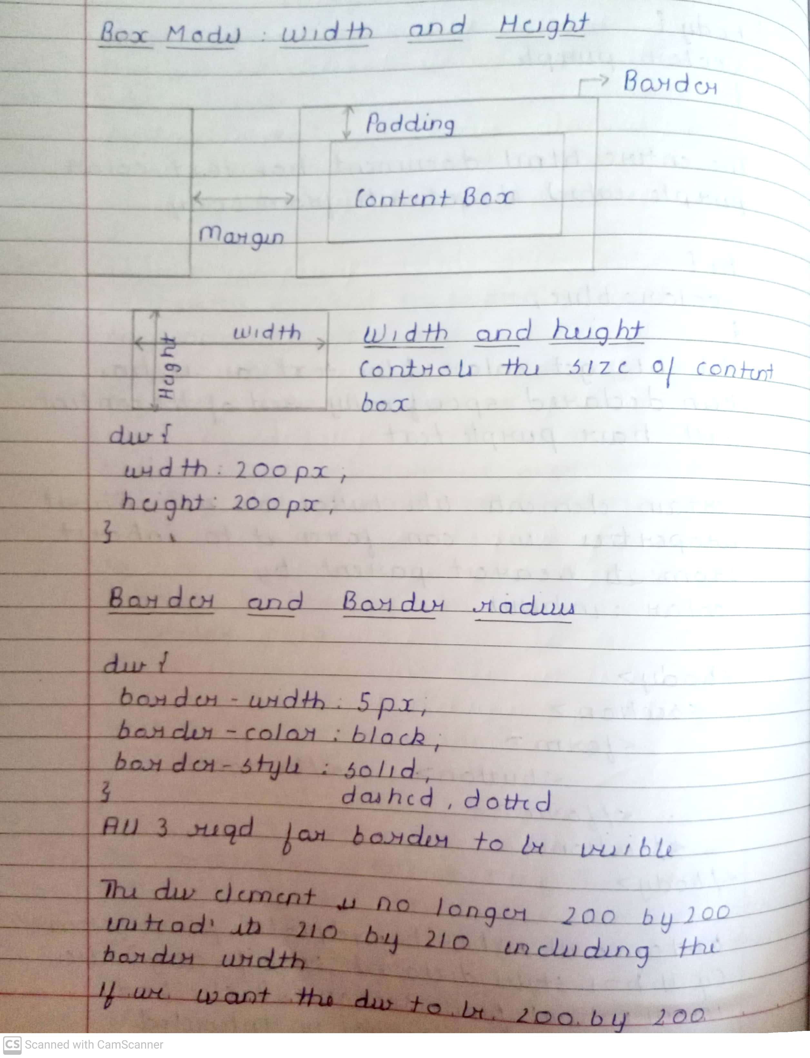

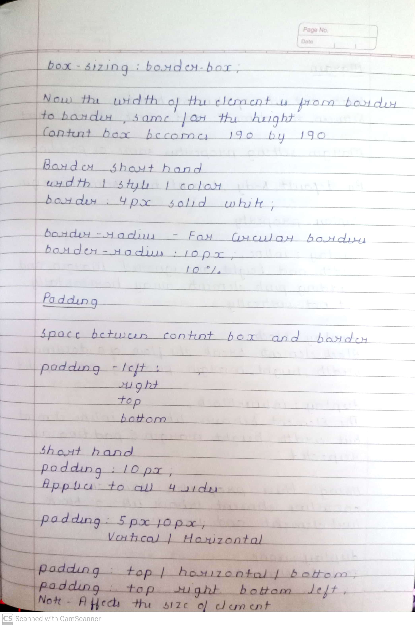

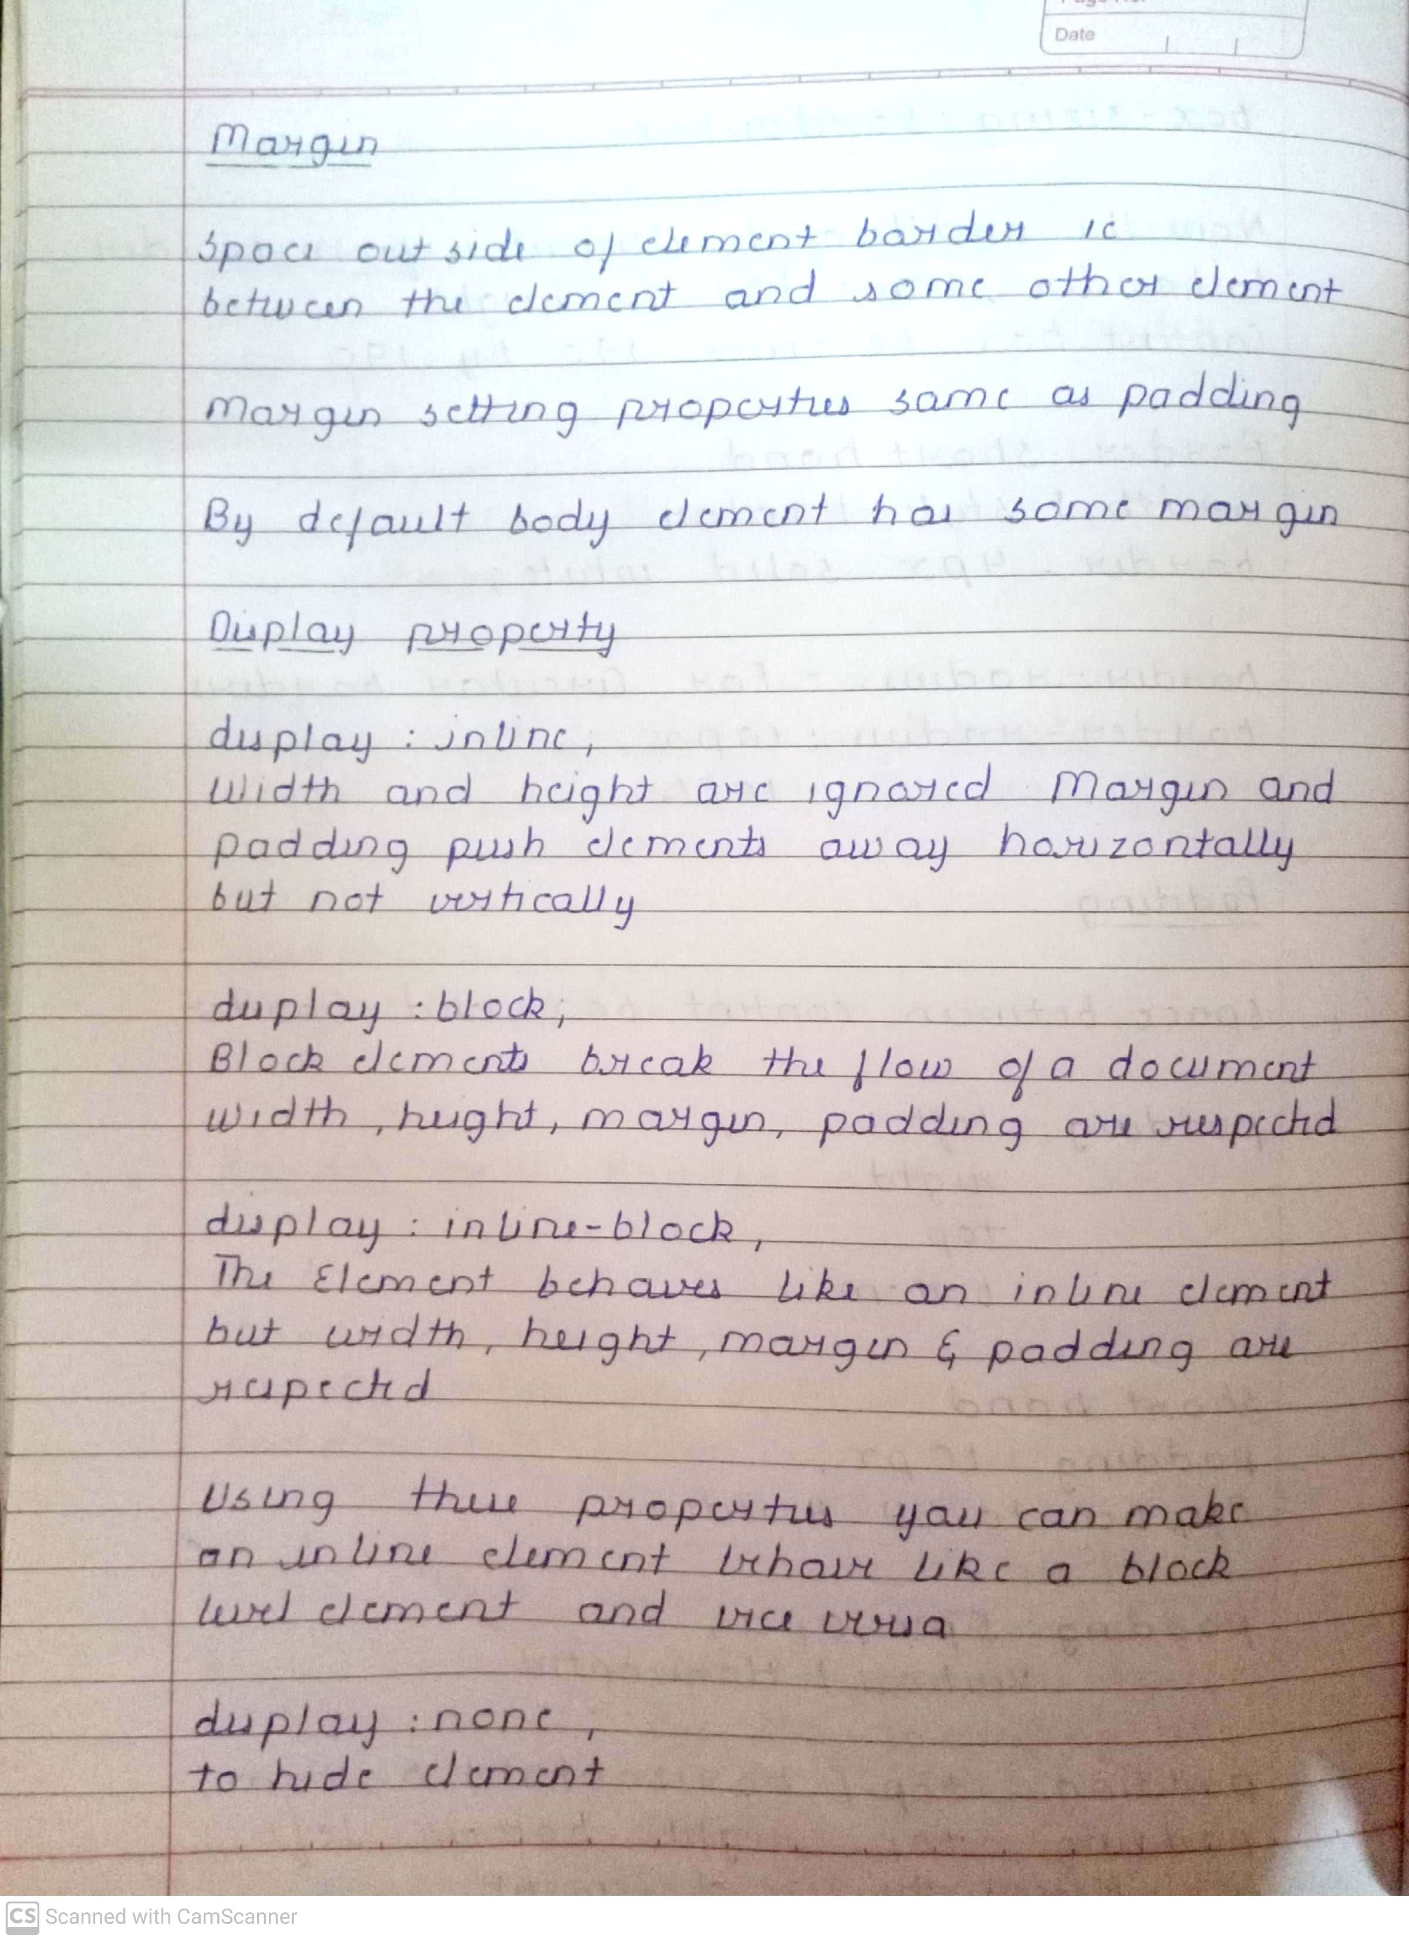

1. To HTML page create in the task 1.a, apply following CSS

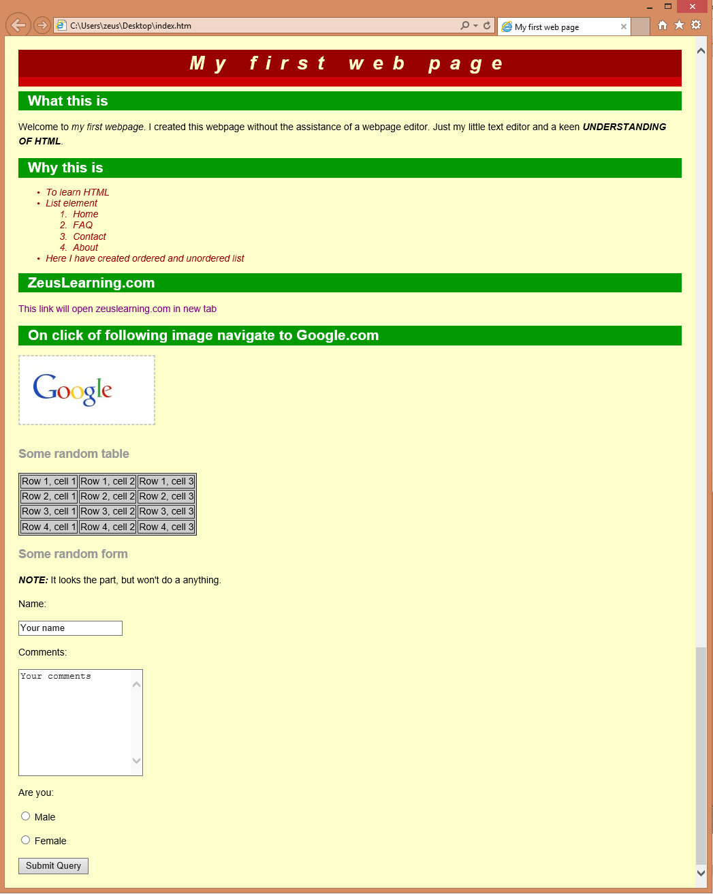

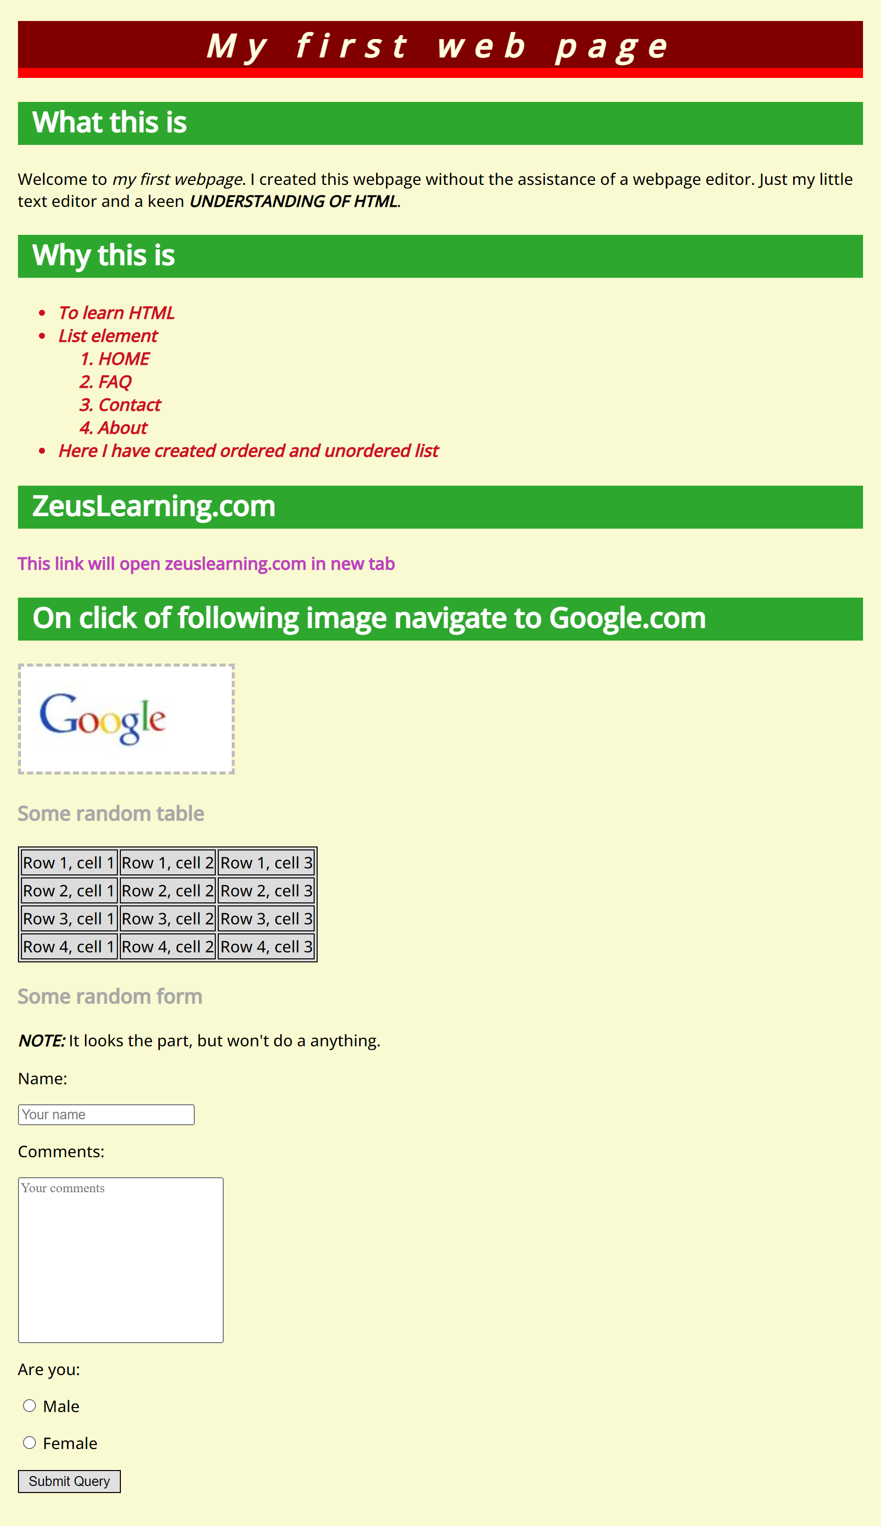

# JavaScript

1. List down ways in which JavaScript command can be added to a webpage, what is the preferred way.

JavaScript can be added to the HTML using script tag and writing the code itself inside the HTML page and secondly including it as an external file and it is ideal to link JavaScript as an external file for the same reason as linking css as an external file as HTML must only be used for structuring website and it allows reusability the code.

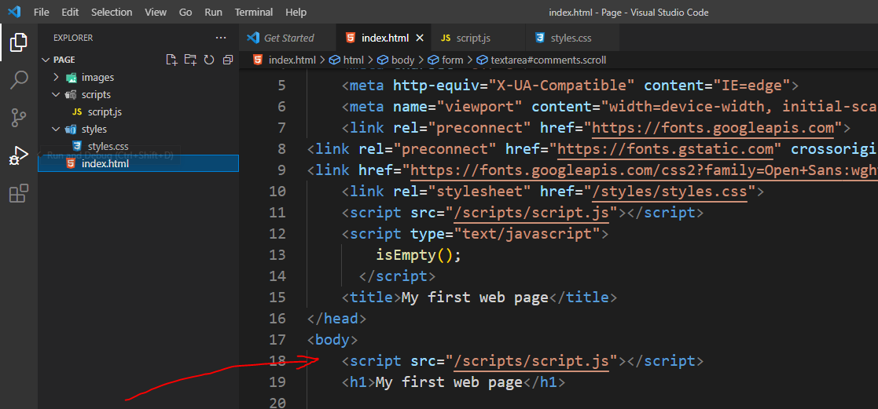

1. To the webpage created in the task 2.d , on click of “Submit” button call JavaScript function to validate:
   1. Name and comments fields are not empty.
   2. User has selected one entry from male/female radio button
   3. In case user has not entered data for name and comment field or not selected anything from male/female radio button – show alert message “All fields are compulsory” and set focus to the first filed that is empty.

